Wettengel Elementary  Red Ribbon Week | 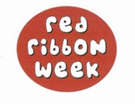  Theme: “Be Happy. Be Brave. Stay Drug-Free” October 23-31, 2020 Red Ribbon Week
10/23: WEAR ORANGE for UNITY DAY against BULLYING! | Home Decoration:  Ask students to design and decorate their door using the theme : “Be Happy. Be Brave. Be drug free”
10/24: WEAR GLOVES day to say  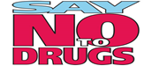 | 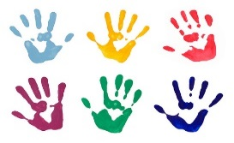  Have students make an image of their handprint on red paper, decorate it with the Drug –Free Pledge, and display the handprints all over your home.
10/25: PUT a CAP on DRUGS DAY (Hat Day) | Wear hats or caps to show their support for a drug-free lifestyle. Make red caps or head bands for students to wear. Prepare or compose a CHEER/CHANT and SHARE during recess time at the Pavilion area.
10/28: SHADE OUT DRUGS DAY (Wear Sunglasses) | 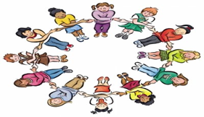  Compose a RAP using the theme and perform during google classroom/meet.  Or create a video about being happy, being brave and being drug free and post on social media
10/29: DESIGN WES Gate with Red Ribbons 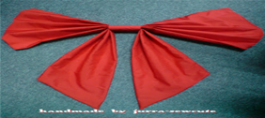 | 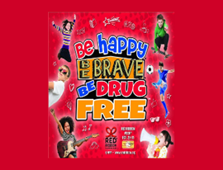  Gather your family and snap that perfect photo for a chance to win $1,000 for your school for drug prevention education, and an iPad for yourself. We can't wait to see your creative photos! Check out redribbon.org for the rules
10/30: PUT A SOCK on DRUGS Wear different colored socks. Dance and sing around your house. | Stomp out illegal drugs in life and walk around the house with decorated socks. Be happy. Be brave. Be drug-free.
10/31: Say “BOO” to drugs and wear costumes to MODEL RESPECT for SELF & OTHERS. | 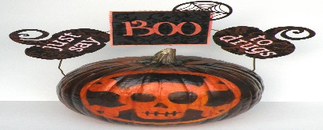  Participate in saying “BOO” to illegal drugs everyday of your life! Show up in your google meet/zoom class in a costume.

Coordinated by: Estela Calata, School Counselor

Acknowledged by: Evangeline E. Iglesias, Principal

